Assignment – 1
Student Name: Ajay Rakwal | UID: 25MCI10329
Section/Group: MAM-1(A) | Semester: 2
Subject Name: Front End Technologies | Subject Code: 25CAH-655

Q1. What is Figma? Explain its key features and why it is widely used in modern UI/UX design.
Ans. Figma is a cloud-based tool used for designing user interfaces and user experiences for websites and mobile apps. It works directly in the browser, so designers do not need to install heavy software. Multiple people can work on the same design file at the same time, which makes teamwork easier.
Some important features of Figma are:
- Real-time collaboration
- Easy sharing through links
- Reusable components and styles
- Built-in prototyping feature
Because of these features, Figma is widely used in modern UI/UX design for faster and smoother work.

Q2. Differentiate between Designing and Prototyping in Figma. Explain with one real-world UI example.
Ans. Designing in Figma is mainly about how the interface looks. It includes choosing colors, fonts, layouts, and placing buttons or text fields on the screen. It focuses on visual appearance and user friendliness. Prototyping is about how the interface works. It connects different screens and shows what happens when a user clicks or taps on something.
For example, in a login page, designing creates the layout of the page, while prototyping links the Login button to the Home screen.

Q3. What are Components and Styles in Figma? How do they help in maintaining consistency and saving time in large projects?
Ans. Components in Figma are reusable elements like buttons, headers, or cards that can be used multiple times. Styles are predefined settings for colors, text, and effects. They help keep the design consistent across all screens.
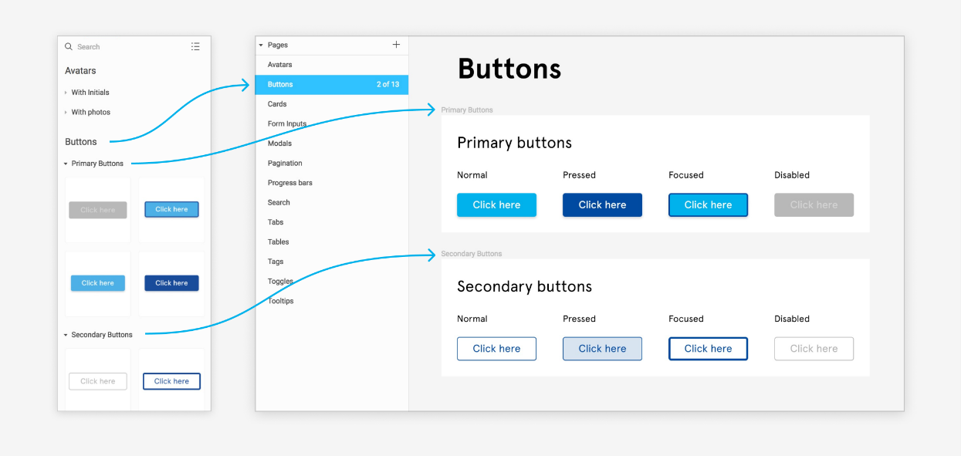
In large projects, components and styles save time because changes made once are updated everywhere. They also help teams maintain a uniform design, making the final product look professional and well-organized.

Q4. Explain Auto-Layout in Figma. How does it help in creating responsive designs for different screen sizes?
Ans. Auto-Layout is a feature in Figma that automatically adjusts the size and spacing of elements. It helps in creating flexible and responsive designs.
Key points about Auto-Layout:
- Adjusts size when content changes
- Maintains proper spacing and alignment
- Useful for mobile and web screens
This feature makes designing for different screen sizes much easier.

Q5. Describe the complete developer handoff process in Figma. How are designs shared, assets exported, and code snippets generated for developers?
Ans. The developer handoff process starts once the design is finalized. The designer shares the Figma file using a link. Developers can view measurements, colors, and fonts using Inspect mode. Figma also provides ready code snippets for CSS, Android, and iOS. Images and icons can be exported in required formats. This process reduces confusion and helps developers build the design accurately.

